

DEPARTMENT OF INFORMATION TECHNOLOGY 24ITT32 - PROGRAMMING IN JAVA

INDIVIDUAL PROJECT ON ACADEMIC MANAGEMENT SYSTEM

P R O J E C T R E P O R T
Submitted by
VEERAVIGNESHWAR K V -25ITR168

JAVA ASSIGNMENT

AIM:
Development of Kongu Engineering College (R2024) Student Academic &
Continuous Evaluation System using Java JDBC.

OBJECTIVE:
Design and develop a database-driven Java application using JDBC to manage student records, perform incremental marks entry (Continuous Internal Assessments and End Semester Examinations), enforce attendance eligibility rules, and generate formal academic performance reports according to Kongu Engineering College (Autonomous) - Regulation 2024. System Requirements & Specifications.

FLOW CHART:
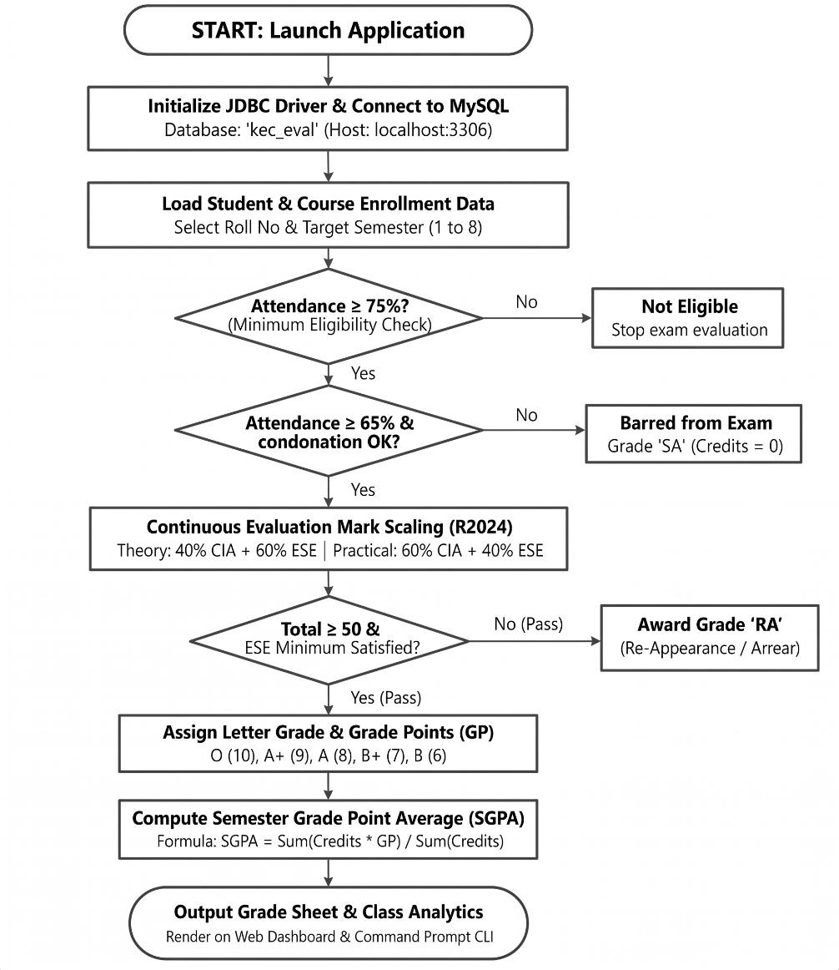

PROCEDURE:
- Load the MySQL Connector/J driver to enable communication between the Java application and the MySQL database.

- Establish a connection to the kec_eval database running on the local MySQL server using DriverManager.getConnection().

- Store and retrieve student details, including roll number, name, department, and semester, along with course information such as course code, title, credits, and course type.

- Enroll students in semester courses, record the number of classes held and attended, and calculate the attendance percentage.

- Verify examination eligibility based on attendance percentage. Students with 75% or above are eligible, those with 65%–74% require medical condonation verification, and those below 65% are marked as Shortage of Attendance (SA).

- Record CIA-1, CIA-2, and assignment marks, and calculate the scaled internal assessment marks according to the specified theory and practical course weightages.

- Record end-semester examination marks out of 100, verify the minimum passing requirements, and scale the marks according to the applicable theory and practical .

- Calculate the total marks by combining scaled CIA and ESE marks. Assign letter grades and grade points according to the specified grading scale, marking students as RA if they fail the examination or score below the required passing mark.

- Generate student grade sheets, attendance shortage reports, and department-wise pass percentage reports. Display the results through the interactive web dashboard and the command prompt console.

DATABASE SCHEMA:

- STUDENTS TABLE:
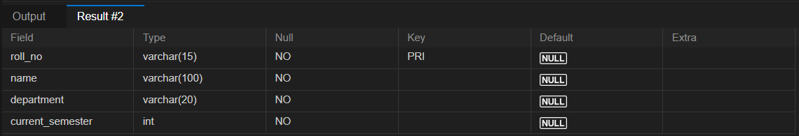

COURSES TABLE:

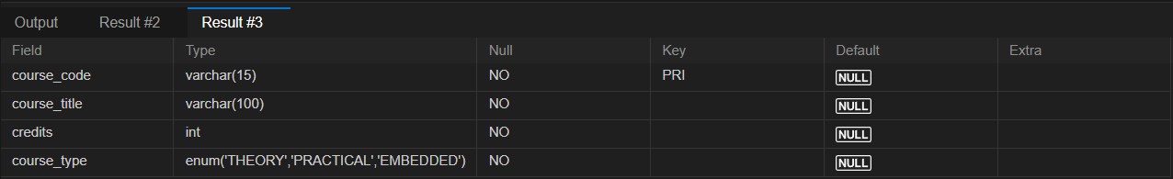

ENROLLMENTS TABLE:

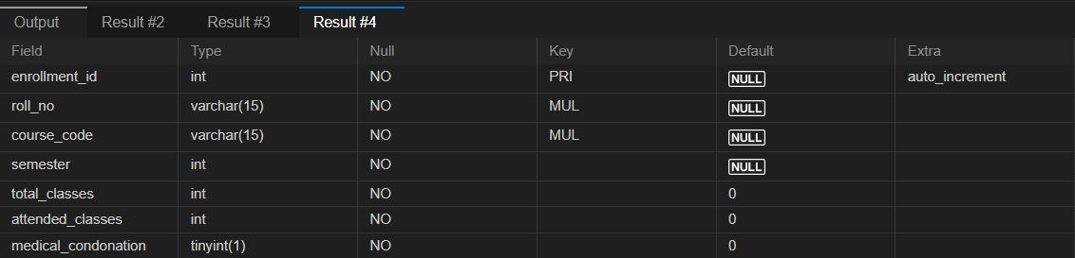

ASSESSMENT MARKS TABLE:
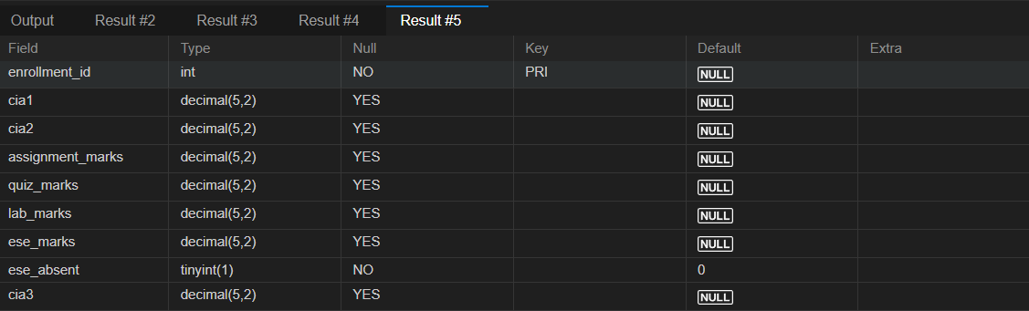

SOURCE CODE: MAINAPP.JAVA:

package com.kec.academic;

import java.sql.SQLException;
import java.util.Scanner;

public class MainApp {

private static final Scanner scanner = new Scanner(System.in);

private static final StudentDAO studentDAO = new StudentDAO();
private static final CourseDAO courseDAO = new CourseDAO();
private static final EnrollmentDAO enrollmentDAO = new EnrollmentDAO();
private static final AttendanceDAO attendanceDAO = new AttendanceDAO();
private static final AssessmentDAO assessmentDAO = new AssessmentDAO();
private static final GradeDAO gradeDAO = new GradeDAO();
private static final GradeResultDAO gradeResultDAO = new GradeResultDAO();
private static final SGPACalculator sgpaCalculator = new SGPACalculator();
private static final FinalGradeService finalGradeService = new FinalGradeService();
private static final AssessmentWeightageMenu weightageMenu =
new AssessmentWeightageMenu();

public static void main(String[] args) {
System.out.println("KEC ACADEMIC PERFORMANCE MANAGEMENT SYSTEM");

while (true) {
displayMenu();
System.out.print("Enter your choice: ");
String choice = scanner.nextLine().trim();

try {
switch (choice) {
case "1" -> studentMenu();
case "2" -> courseMenu();
case "3" -> enrollmentMenu();
case "4" -> attendanceMenu();
case "5" -> assessmentMenu();
case "6" -> gradeReportMenu();
case "7" -> calculateSGPA();
case "8" -> weightageMenu.showMenu(scanner);
case "0" -> {
System.out.println("Thank you for using KEC Academic System!");
scanner.close();
return;
}
default -> System.out.println("Invalid choice!");
}
} catch (SQLException e) {
System.out.println("Database operation failed: " + e.getMessage());
} catch (Exception e) {
System.out.println("Operation failed: " + e.getMessage());
}
}
}

private static void displayMenu() {
System.out.println("""

---------- MAIN MENU ----------
1. Student Management
2. Course Management
3. Enrollment Management
4. Attendance Management
5. Assessment Management
6. View Grade Report
7. Calculate SGPA
8. Assessment Weightage Configuration
0. Exit
""");
}

private static void studentMenu() throws SQLException {
System.out.println("1. Add Student 2. View Students");
System.out.println("3. Search Student 4. Update Student");
System.out.println("5. Delete Student 0. Back");
String choice = scanner.nextLine().trim();

switch (choice) {
case "1" -> addStudent();
case "2" -> studentDAO.viewAllStudents();
case "3" -> studentDAO.searchStudent(readText("Roll number: "));
case "4" -> updateStudent();

case "5" -> deleteStudent();
default -> { }
}
}
private static void addStudent() throws SQLException {
String roll = readText("Roll number: ");
String name = readText("Student name: ");
String dept = readText("Department: ");
int sem = readInteger("Semester: ");
studentDAO.addStudent(roll, name, dept, sem);
}

private static void updateStudent() throws SQLException {
String roll = readText("Roll number: ");
String name = readText("New name: ");
String dept = readText("New department: ");
int sem = readInteger("New semester: ");
studentDAO.updateStudent(roll, name, dept, sem);
}

private static void deleteStudent() throws SQLException {
String roll = readText("Roll number: ");
if (readText("Confirm deletion (yes/no): ").equalsIgnoreCase("yes"))
studentDAO.deleteStudent(roll);
}

private static void courseMenu() throws SQLException {
System.out.println("1. Add Course 2. View Courses");
System.out.println("3. Search Course 0. Back");
switch (scanner.nextLine().trim()) {
case "1" -> courseDAO.addCourse(
readText("Course code: "), readText("Course title: "),
readInteger("Credits: "), readText("Type: ").toUpperCase());
case "2" -> courseDAO.viewAllCourses();
case "3" -> courseDAO.searchCourse(readText("Course code: "));
default -> { }
}
}

private static void enrollmentMenu() throws SQLException {
System.out.println("1. Enroll Student 2. View Enrollments 0. Back");
switch (scanner.nextLine().trim()) {
case "1" -> enrollmentDAO.enrollStudent(
readText("Roll number: "), readText("Course code: "),
readInteger("Semester: "));
case "2" -> enrollmentDAO.viewEnrollments();
default -> { }
}
}

private static void attendanceMenu() throws SQLException {
System.out.println("1. Update Attendance 2. Update Condonation");

System.out.println("3. View Attendance Report 0. Back");
switch (scanner.nextLine().trim()) {
case "1" -> attendanceDAO.updateAttendance(
readInteger("Enrollment ID: "),
readInteger("Total classes: "),

readInteger("Attended classes: "));
case "2" -> attendanceDAO.updateCondonation(
readInteger("Enrollment ID: "),
readText("Approved? (yes/no): ").equalsIgnoreCase("yes"));
case "3" -> attendanceDAO.viewAttendanceReport();
default -> { }
}
}

private static void assessmentMenu() throws SQLException {
System.out.println("1. Enter Marks 2. View Assessments 0. Back");
if (scanner.nextLine().trim().equals("2"))
assessmentDAO.viewAssessments();
else
System.out.println("Use the full assessment input implementation to enter marks.");
}

private static void gradeReportMenu() throws SQLException {
System.out.println("1. Student Grade Details");
System.out.println("2. Saved Final Grades");
System.out.println("3. Calculate and Save Grades");
String roll = readText("Roll number: ");

switch (scanner.nextLine().trim()) {
case "1" -> gradeDAO.viewStudentGradeDetails(roll);
case "2" -> gradeResultDAO.viewGrades(roll);
case "3" -> finalGradeService.calculateGradesForStudent(roll);
default -> { }
}
}

private static void calculateSGPA() throws SQLException {
String roll = readText("Roll number: ");
int sem = readInteger("Semester: ");
sgpaCalculator.calculateSGPA(roll, sem);
}

private static String readText(String prompt) {
System.out.print(prompt);
return scanner.nextLine().trim().toUpperCase();
}

private static int readInteger(String prompt) {
while (true) {
try {

System.out.print(prompt);
return Integer.parseInt(scanner.nextLine().trim());
} catch (NumberFormatException e) {
System.out.println("Enter a valid whole number.");
}
}
}

DB CONNECTION.JAVA:

package com.kec.academic;

import java.sql.Connection;
import java.sql.DriverManager;
import java.sql.SQLException;

public class DBConnection {

private static final String URL =
"jdbc:mysql://localhost:3306/kec_academics";

private static final String USER = "root";

public static Connection getConnection() throws SQLException {

String password = System.getenv("KEC_DB_PASSWORD");

if (password == null || password.isBlank()) {
throw new SQLException(
"Database password not found. Set KEC_DB_PASSWORD first."
);
}

return DriverManager.getConnection(URL, USER, password);
}
}

OUTPUT SCREENSHOTS:

MAIN MENU:

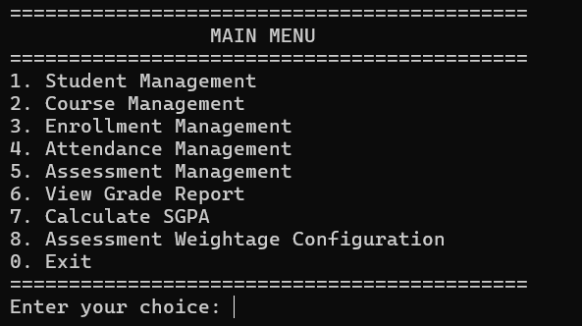

STUDENT & COURSE MANAGEMENT:

STUDENT REGISTRATION:
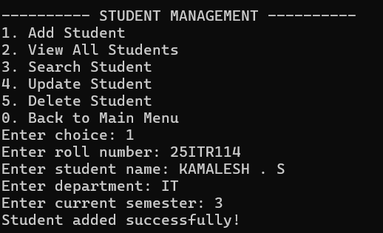

COURSE CATALOG:
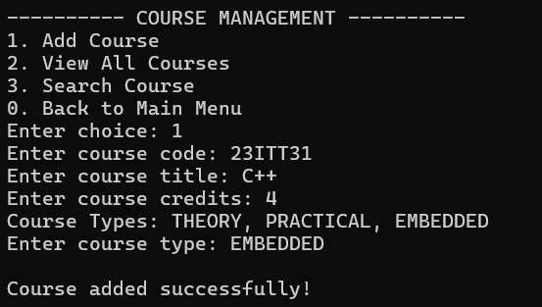

COURSE ENROLLMENT & ATTENDANCE TRACKING:
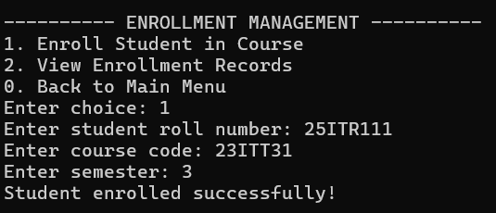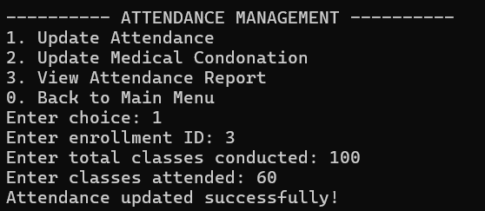

INCREMENTAL MARKS ENTRY:

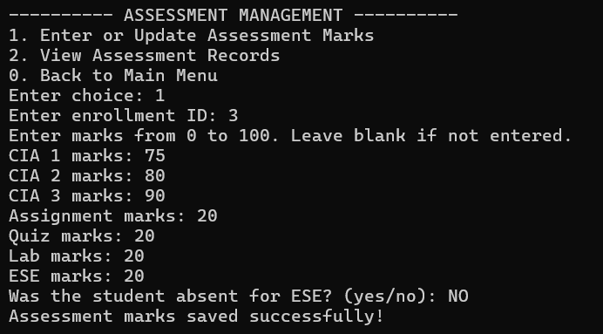

ATTENDANCE & GRADING RULES:

ATTENDANCE FILTER:
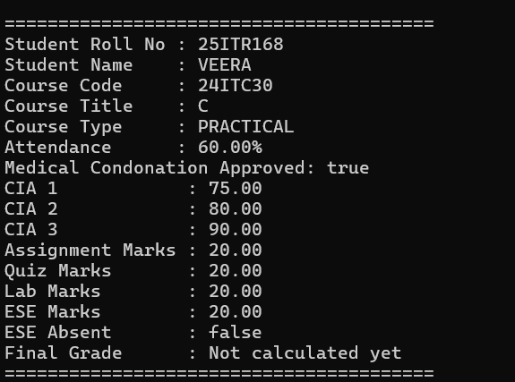

STUDENT MARK :
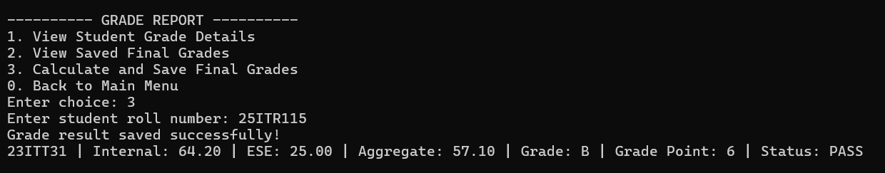

DATABASE:

STUDENTS DATABASE:

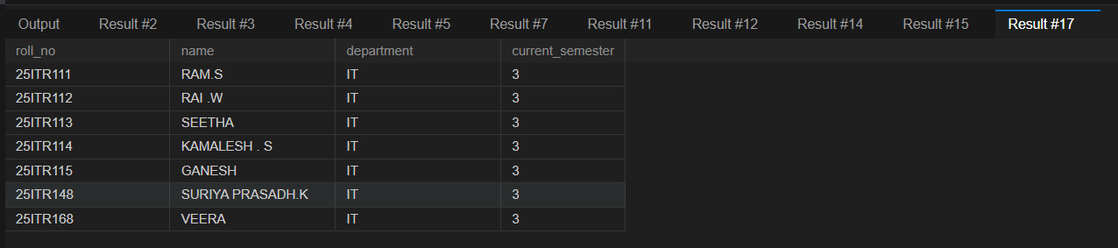

COURSES DATABASE:
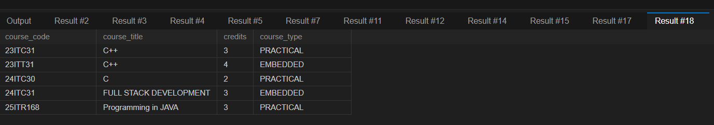

ENROLLMENTS DATABASE:
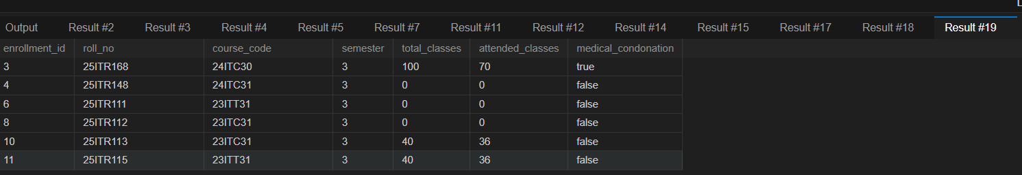

RESULT:

Thus, the Student Academic and Continuous Evaluation System for Kongu Engineering College (Autonomous) Regulation 2024 was successfully designed, developed, and tested using Java (JDBC) and MySQL. The system accurately automates the calculation of Continuous Internal Assessments (CIA), End Semester Examinations (ESE), Letter Grades, Attendance Eligibility, and Semester Grade Point Average (SGPA).

REFERENCES:
- Oracle, Java SE Documentation – JDBC Overview and Architecture. https://docs.oracle.com/javase/8/docs/technotes/guides/jdbc/ .
- Oracle, Java SE API – HttpServer. https://docs.oracle.com/en/java/javase/17/docs/api/jdk.httpserver/com/sun/net/httpserve r/HttpServer.html .
- Oracle, MySQL 8.0 Reference Manual. https://dev.mysql.com/doc/refman/8.0/en/ .

- Oracle, MySQL Connector/J Developer Guide. https://dev.mysql.com/doc/connector-j/8.0/en/ .
- University Grants Commission, Guidelines for Choice Based Credit System (CBCS). https://www.ugc.gov.in/pdfnews/8023719_Guidelines-for-CBCS.pdf .
- Chart.js, Chart.js Documentation. https://www.chartjs.org/docs/latest/ .

- Tailwind CSS, Tailwind CSS Documentation. https://tailwindcss.com/docs .

- GeeksforGeeks, Establishing JDBC Connection in Java. https://www.geeksforgeeks.org/establishing-jdbc-connection-in-java/ .
- YouTube, Java JDBC with MySQL Tutorial Videos. https://www.youtube.com/results?search_query=Java+JDBC+MySQL+tutorial .
- Anthropic, Claude AI Assistant (used for project ideas and guidance). https://claude.ai/ .

GITHUB:

LINK:

